EXPERIMENT-3

NAME:Sri Vaishnavi A ROLL NO:240701529

- COMMAND LINE INTERFACE:
PYTHON CODE:
import os
import sys

def rename_file(old_name, new_name):
try:
os.rename(old_name, new_name)
print(f"File renamed from {old_name} to {new_name}")
except FileNotFoundError:
print(f"Error: {old_name} not found.")
except Exception as e:
print(f"An error occurred: {e}")

if __name__ == "__main__":
if len(sys.argv) != 3:
print("Usage: python rename_file_cli.py <old_filename> <new_filename>")
else:
rename_file(sys.argv[1], sys.argv[2])
OUTPUT:

2.VOICE USER INTERFACE:

import speech_recognition as sr
import os
def rename_file_from_voice_command(command):
try:
old_name = "old.txt" # fixed old file name
new_name = command.lower().strip()
if not os.path.exists(old_name):
print(f"Error: File '{old_name}' not found.")
return

os.rename(old_name, new_name)
print(f"File renamed from '{old_name}' to '{new_name}'")

except Exception as e:
print(f"Error: {e}")

def listen_for_command():
recognizer = sr.Recognizer()

with sr.Microphone() as source:
print("Listening... Say the new file name")
recognizer.adjust_for_ambient_noise(source)
audio = recognizer.listen(source)

try:
command = recognizer.recognize_google(audio)
print("You said:", command)

rename_file_from_voice_command(command)

except sr.UnknownValueError:
print("Sorry, I couldn't understand.")

except sr.RequestError as e:
print("Speech recognition error:", e)

if __name__ == "__main__":
listen_for_command()

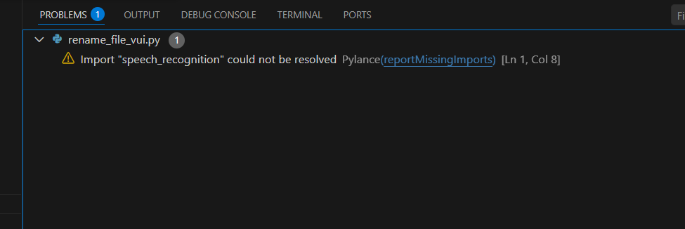

3.GRAPHICAL USER INTERFACE

import tkinter as tk
from tkinter import messagebox
import os

def rename_file():
old_name = old_filename_entry.get().strip()
new_name = new_filename_entry.get().strip()

if not old_name or not new_name:
messagebox.showwarning("Warning", "Please enter both filenames!")
return

if not os.path.exists(old_name):
messagebox.showerror("Error", f"File '{old_name}' not found.")
return

if os.path.exists(new_name):
overwrite = messagebox.askyesno("Warning", f"'{new_name}' already exists. Overwrite?")
if not overwrite:
return

try:
os.rename(old_name, new_name)
messagebox.showinfo("Success", f"File renamed from '{old_name}' to '{new_name}'")
except Exception as e:
messagebox.showerror("Error", f"An error occurred: {e}")

root = tk.Tk()
root.title("File Renamer")
root.geometry("400x150")
root.resizable(False, False)

tk.Label(root, text="Old Filename:").grid(row=0, column=0, padx=10, pady=5, sticky="w")
tk.Label(root, text="New Filename:").grid(row=1, column=0, padx=10, pady=5, sticky="w")

old_filename_entry = tk.Entry(root, width=40)
old_filename_entry.grid(row=0, column=1, padx=10, pady=5)

new_filename_entry = tk.Entry(root, width=40)
new_filename_entry.grid(row=1, column=1, padx=10, pady=5)

rename_button = tk.Button(root, text="Rename File", bg="green", fg="white",
command=rename_file)
rename_button.grid(row=2, column=0, columnspan=2, pady=10)

root.mainloop()
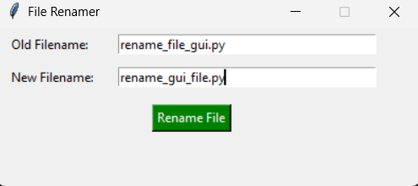

- 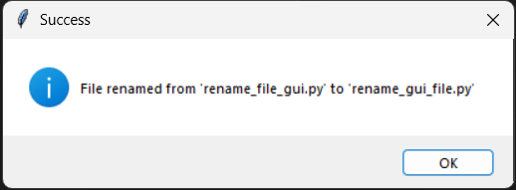
4. USER SATISFACTION COMPARISON:

def survey():
print("Rate your satisfaction with the following interfaces (1-5):")

try:
cli_satisfaction = int(input("CLI (1-5): "))
gui_satisfaction = int(input("GUI (1-5): "))
vui_satisfaction = int(input("VUI (1-5): "))

if not (1 <= cli_satisfaction <= 5 and
1 <= gui_satisfaction <= 5 and
1 <= vui_satisfaction <= 5):
print("Please enter ratings between 1 and 5 only.")
return

print("\nYour satisfaction ratings:")
print(f"CLI: {cli_satisfaction}")
print(f"GUI: {gui_satisfaction}")
print(f"VUI: {vui_satisfaction}")

avg_satisfaction = (cli_satisfaction + gui_satisfaction + vui_satisfaction) / 3
print(f"\nAverage Satisfaction Score: {avg_satisfaction:.2f}")

except ValueError:
print("Invalid input! Please enter numbers between 1 and 5.")

if __name__ == "__main__":
survey()

